Calculate **239 + 182**

Match each question to the correct answer.

6 x 5 30

Half of 98 32

Double 4 x 4 44

49

Put these times in order, starting with the shortest.

5 minutes

20 seconds

1 minute

100 seconds

Park School collects money for three charities. This pictogram shows how much they have collected.

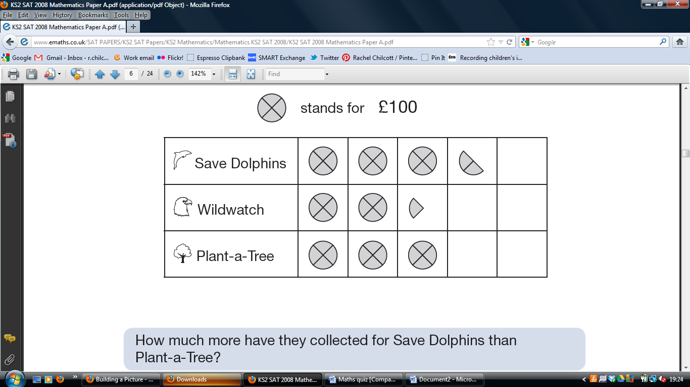

How much more have they collected for Save Dolphins than Plant-a-Tree?

Draw the reflection of the shaded shape in the mirror line



The target for Wildwatch is £500.

How much **more** money do they need to collect for Wildwatch?

A square always has four sides.

Is it true that a four-sided shape is **always** a square?

The numbers in this sequence increase by 75 each time.

Write in the two missing numbers.

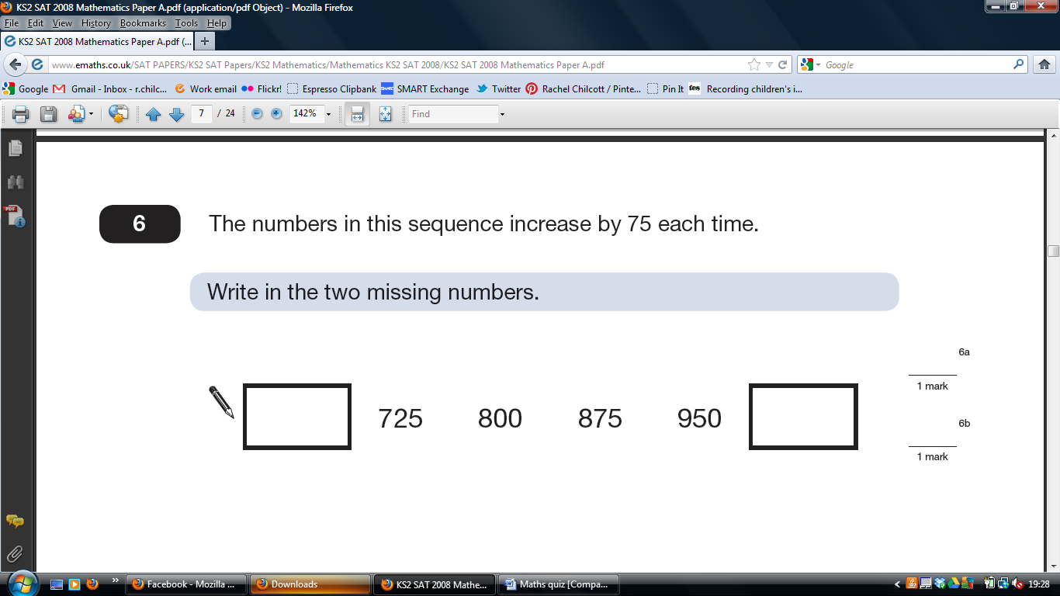



On a sheet of stickers there are 5 circles, 2 stars and one rectangle.

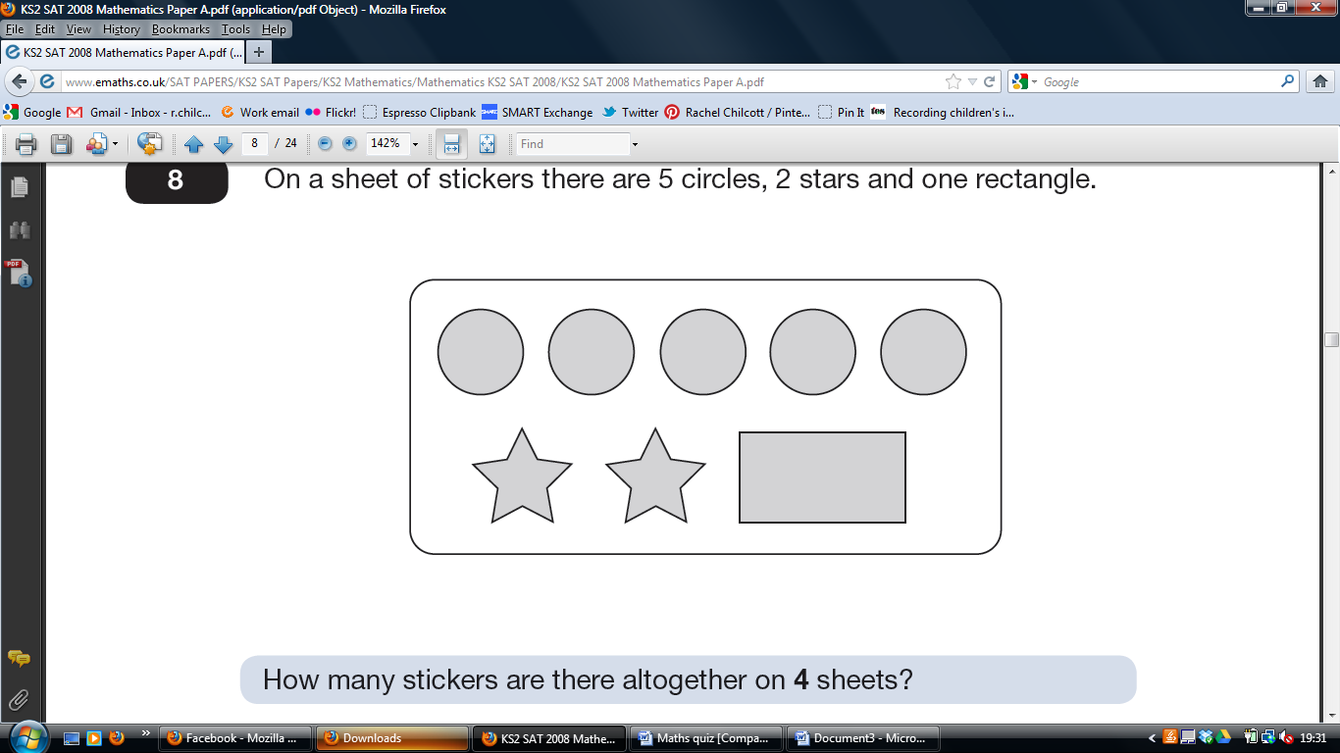

Nisha needs 55 circles.

How many sheets of stickers does she need?

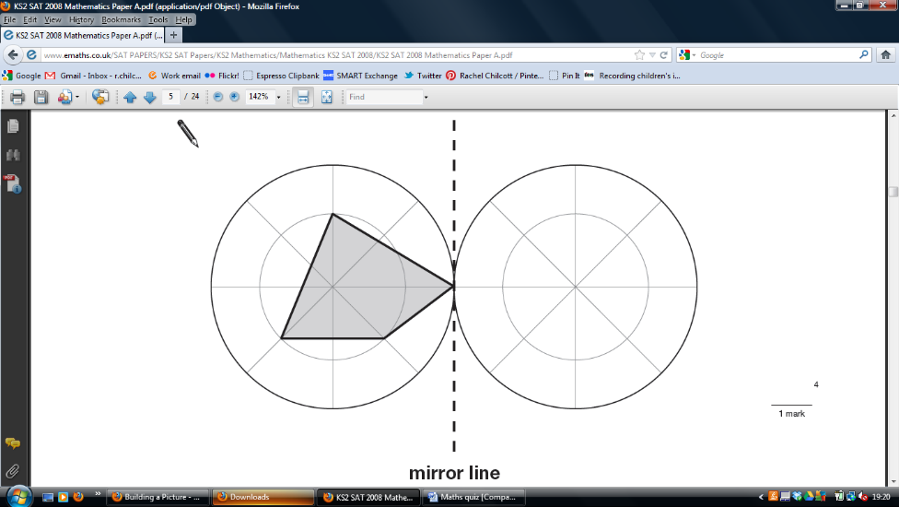

Here is a number chart.

Circle the **smallest** number on the chart that is a multiple of **both** 2 and 7.

71 72 73 74 75 76 77 78 79 80 81 82 83 84 85 86 87 88 89 90 91 92 93 94 95 96 97 98 99 100

On a sheet of stickers there are 5 circles, 2 stars and one rectangle.



Ben has 10 sheets of stickers.

How many **more** circles than rectangles does he have?

Circle the **largest** number that is **not** a multiple of 2 or 3 or 5.

71 72 73 74 75 76 77 78 79 80 81 82 83 84 85 86 87 88 89 90 91 92 93 94 95 96 97 98 99 100

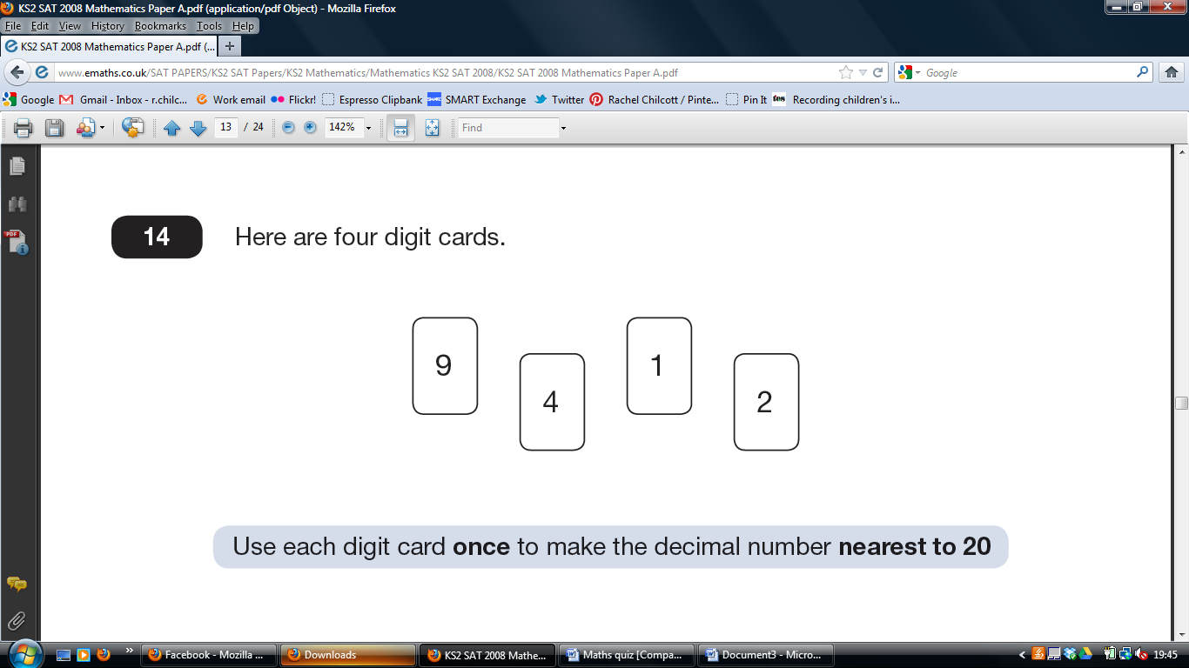

Use each digit card **once** to make the decimal number **nearest to 20.**

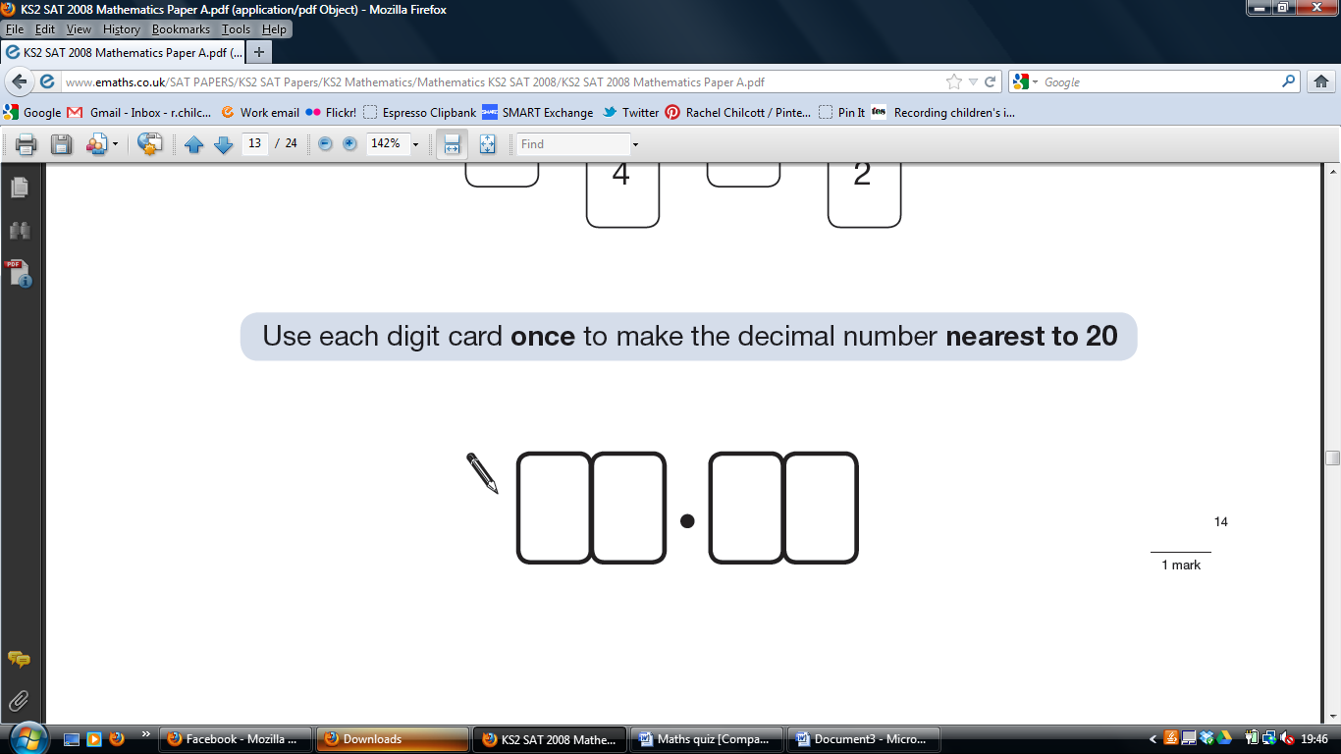

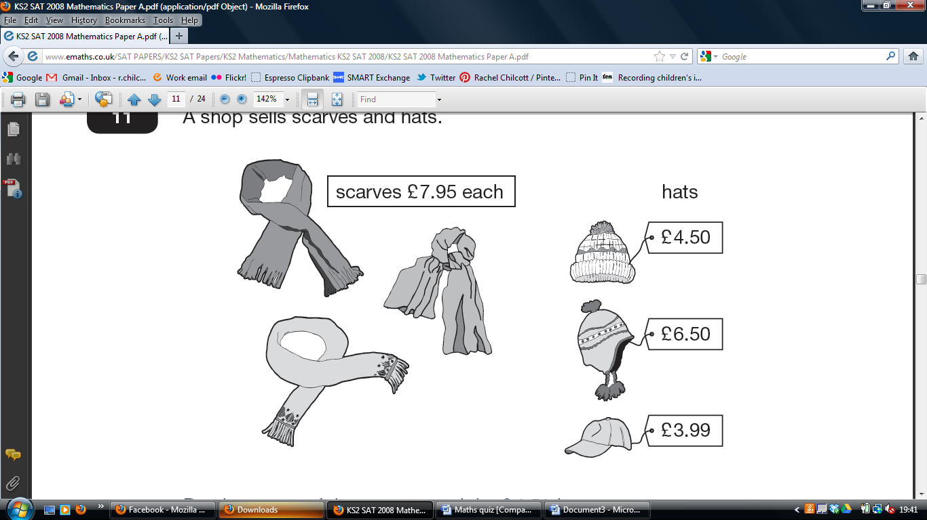

Ben buys one of the scarves and the £4.50 hat.

How much change does he get from £20?

Calculate **364 ÷ 7**

Emily has 6 cubes. She sticks them together to make this model.

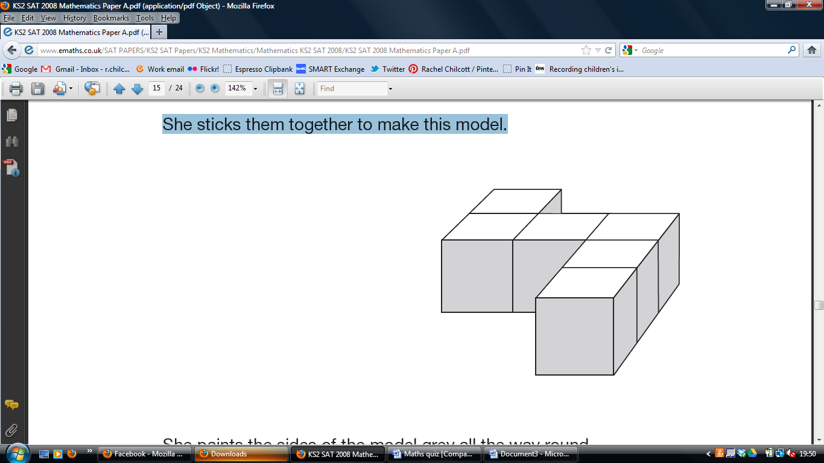

She paints the sides of the model grey all the way round.

She leaves the top and the bottom of the model white.

How many of the cubes in the model have **exactly two** faces

painted grey?

This regular 12-sided shape has a number at each vertex.

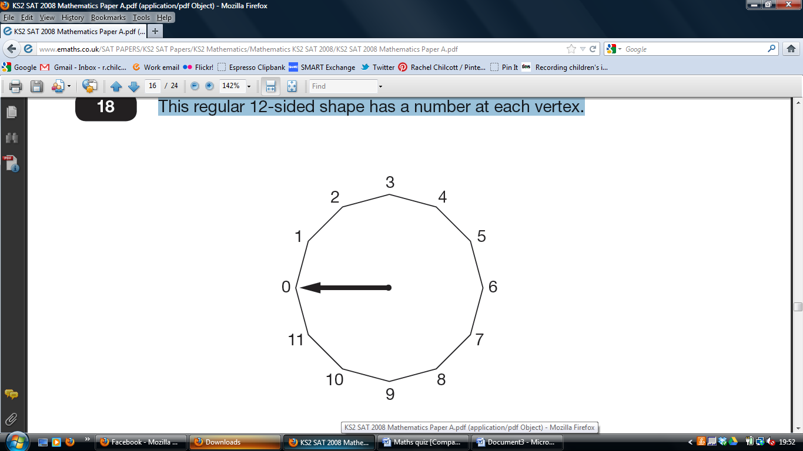

Ben turns the pointer from zero, clockwise through 150°

Which number will the pointer now be at?

Calculate **45.3 × 6**

**Maths Activity Sheet**

Ben thinks of a number.

He adds half of the number to a quarter of the number.

The result is 60

What was the number Ben first thought of?

1/3 of this square is shaded.

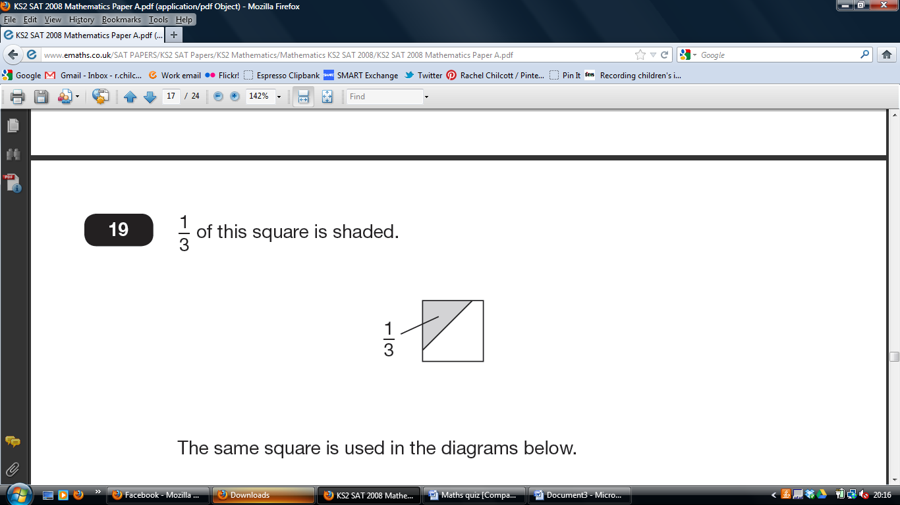

What fraction of this diagram is shaded?

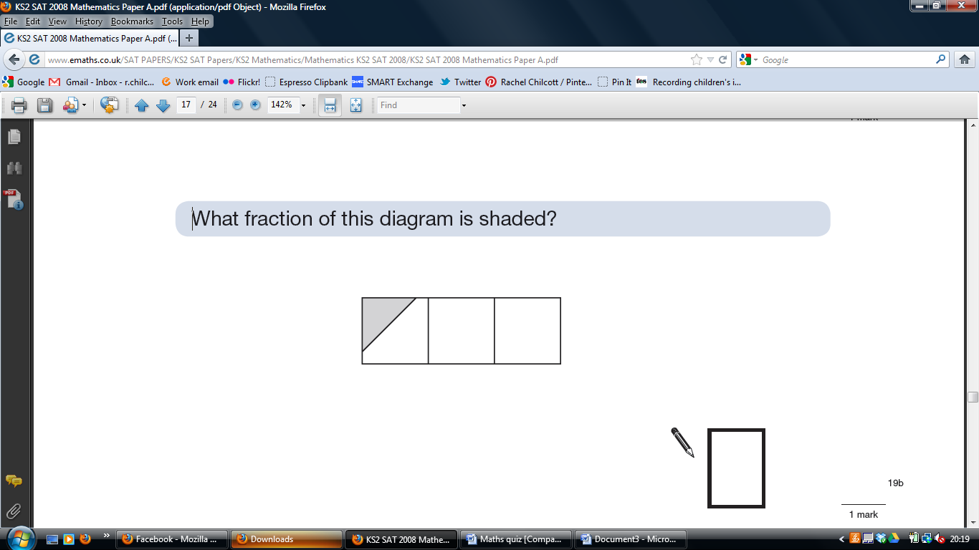

1/3 of this square is shaded.



The same square is used in the diagrams below.

What fraction of this diagram is shaded?

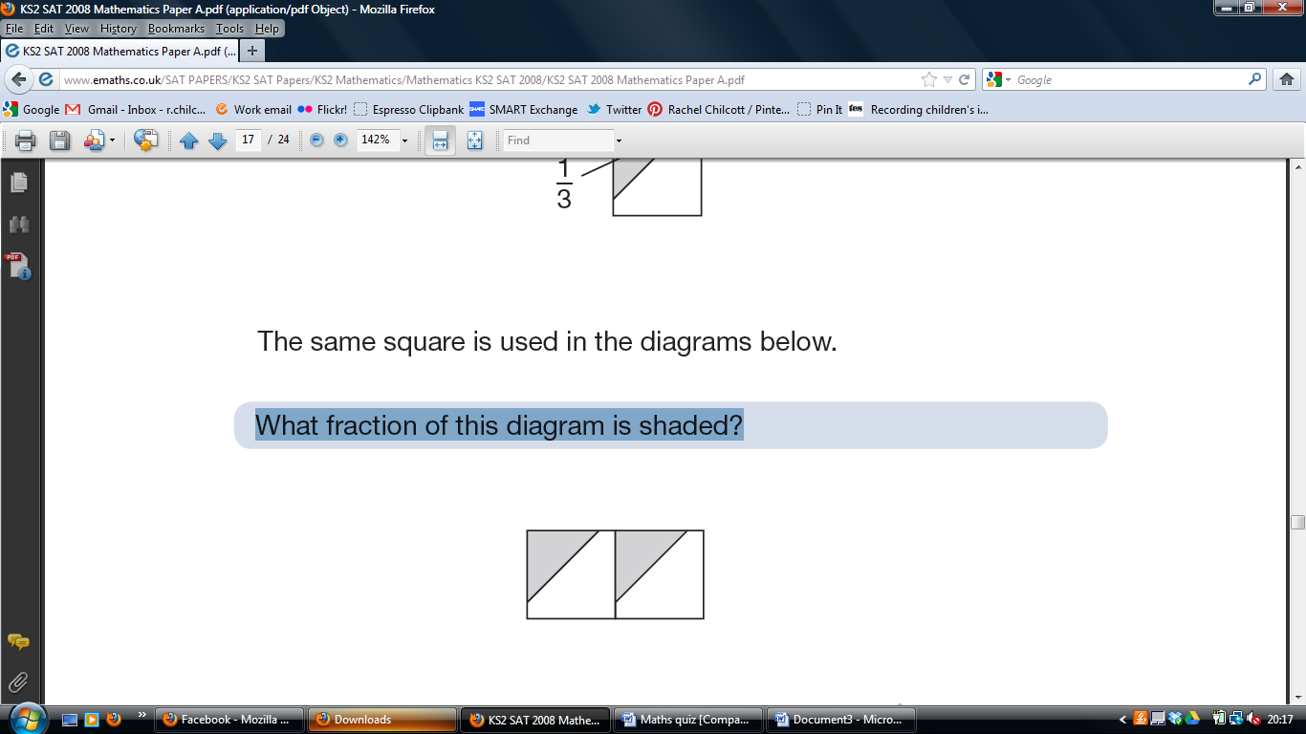

Nisha’s kettle holds 2 litres of water.

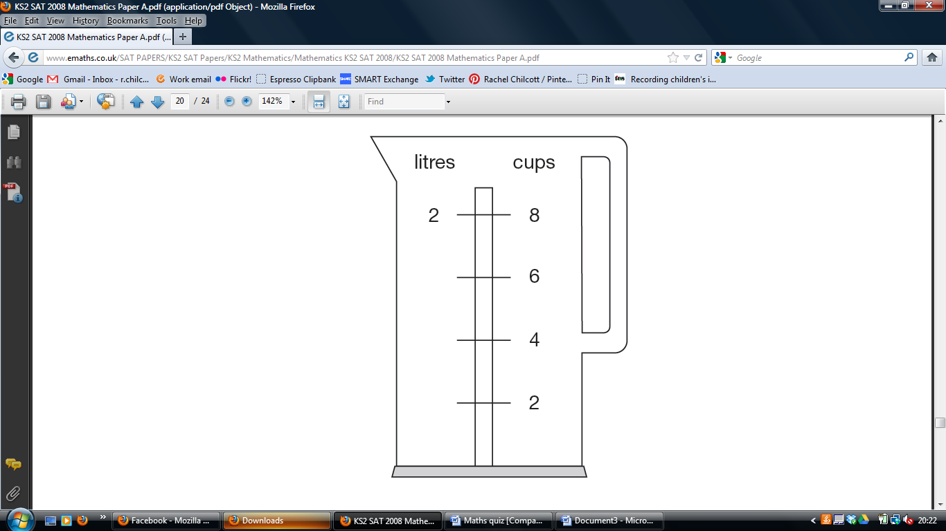

How many millilitres are equal to 1 cup?

Emily makes 250 grams of a snack mixture.

15% of the weight is raisins, 25% is banana chips and

the rest is peanuts.

How many grams of **peanuts** does she use?

The numbers in this sequence increase by 7 each time.

1 8 15 22 29 ....

The sequence continues in the same way.

Will the number 777 be in the sequence?